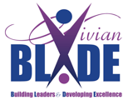

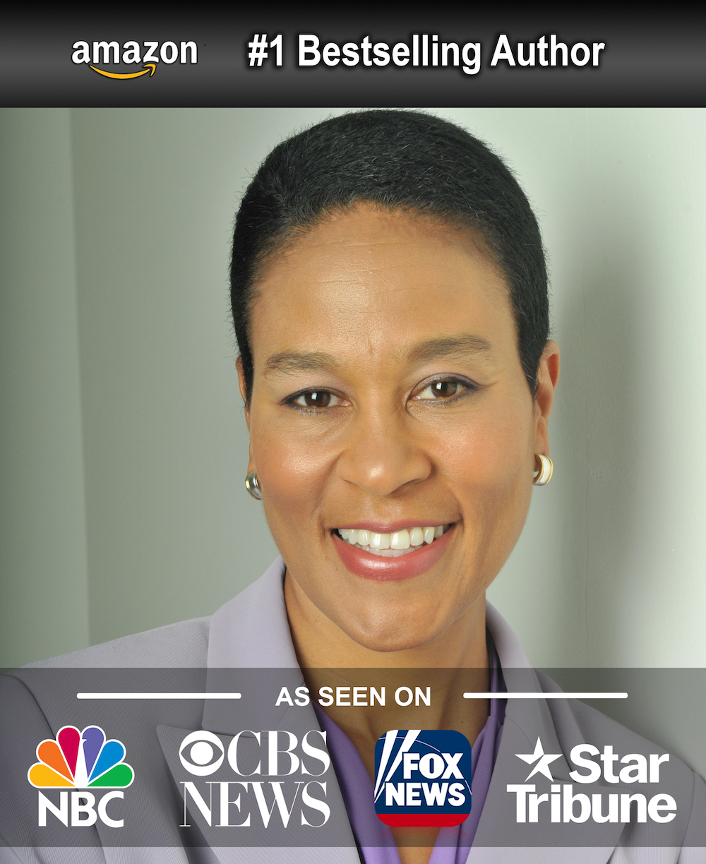

Vivian Hairston Blade, MBA, MBB, PMP
Leadership & Resilience Expert
President & CEO, Experts in Growth Leadership Consulting, LLC

Recognized as one of Engagedly’s Top 100 Global HR Influencers, Vivian Blade is a sought-after leadership expert and thought leader. She works with the world’s top brands to build better, more resilient workplaces, equipping leaders to solve the pressing burnout, turnover, and workplace culture challenges your company is struggling with right now. Her impact is felt as a frequent keynote speaker, and in delivering transformative leadership development programs, executive and team coaching, and corporate consulting.

In her work with the world's top companies, Vivian applies her extensive business, finance and leadership experience from a 20-year corporate career with Humana and GE, to coach and develop aspiring and established leaders in building high-performance, high-quality and high-service level organizations. Her corporate experience as a leader and individual contributor spans product management, marketing, ecommerce, Lean Six Sigma and customer experience. She also works in academia as an Adjunct Professor of Leadership & Organizational Behavior, and Project Management for the University of Louisville College of Business She is the recognized Resilience expert for the University of Louisville’s Project on Positive Leadership, and serves on its Board of Advisors.

Vivian is a prolific writer whose articles, featured in a number of professional, industry, and business publications, and published books have helped thousands of professionals succeed. Her #1 best-selling book Resilience Ready: The Leader’s Guide to Thriving Through Unrelenting Crises reveals the key to living and leading with resilience. Influence in Talent Development, unpacks how to SCALE this essential skill for greater impact. And her book, FuelForward: Discover Proven Practices to Fuel Your Career Forward reveals the inside secrets of career success. She also is a contributor to two additional books published by the Association for Talent Development "Find Your Fit: A Practical Guide to Landing a Job You'll Love", and “Work the Problem: How Experts Tackle Workplace Challenges”.

Vivian fulfills her passion for growing the next generation of confident and competent leaders by volunteering her time on the boards of various organizations.

You may contact Vivian at vivian@vivianblade.com / vivianblade.com or vivian.blade@louisville.edu.

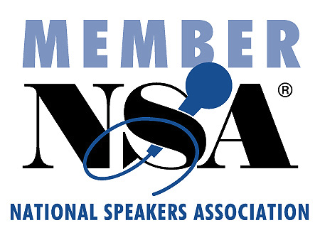
https://VivianBlade.com
https://ResilienceReady.Today
https://InfluenceWithScale.com

LinkedIn: https://www.linkedin.com/in/vivianblade/
Twitter: https://twitter.com/VivianBlade

